G | F | E | D | C | B | A
14.30 | 14.00 | 13.30 | 13.00 | 12.30 | 12.00 | 11.30 | Start Time
 |  |  |  |  |  |  | Team Name/Judges’ Comments
 |  |  |  |  |  |  | Peal Speed
 |  |  |  |  |  |  | Judge %
 |  |  |  |  |  |  | Str’ %
 |  |  |  |  |  |  | Result

NATIONAL TWELVE BELL STRIKING COMPETITION

SHREWSBURY ELIMINATOR

Saturday 28 March 2015

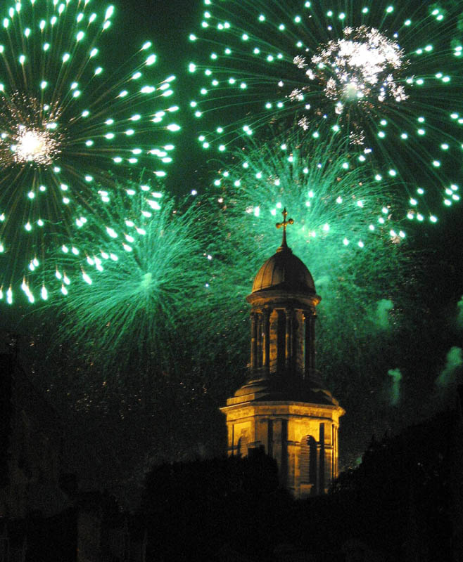

Shrewsbury ringers welcome you

Today’s Timetable

11.00 Welcome and draw in St Chad’s church
11.30 – 15.00 Ringing
16.30 (approx) Judges’ remarks and results, in church

Catering
Snacks will be available in St Chad’s church hall (across the car park from the church) from 10.00 continuously, including bacon or sausage breakfast rolls, a selection of cakes and biscuits, tea, coffee, juices and squashes. We do not have a licence to sell alcohol in the hall.

The nearest pub is the Coach & Horses in Swan Hill, five minutes’ walk from St Chad’s. The pub serves hot meals until about 14.30 and is open for drinking all day.

Across the Quarry Park, opposite the church, is the Boathouse pub beside the river, which also serves food. It has outside seating from where you can hear the bells.

There are numerous places in the town centre for eating and drinking throughout the day.

Toilets
There are toilets in the church hall and public toilets in the Quarry Park, to the right of the blue entrance gates. The toilets in church are reserved for the judges and officials.

Things to do in Shrewsbury
Should you want a break from the ringing contest, Shrewsbury is a fascinating town to explore with numerous narrow passages between streets. In the Square is the medieval market hall (now an arthouse cinema and popular café). Here also, in the Georgian Music Hall, is the museum, and the Tourist Information office. The Roman gallery on the ground floor is free, and well worth a visit. The TI office has numerous trail leaflets.

St Mary’s church at the top of the town contains outstanding medieval glass; the castle beyond was heavily restored by Thomas Telford. From the folly tower in its garden is an exceptional view of the looping river Severn. The handsome stone building opposite the castle, now the town library, was originally Shrewsbury School. Among pupils at different times were Sir Philip Sidney and Charles Darwin.

Beyond the river lies the Norman church of the former Benedictine abbey, well known for Brother Cadfael, the medieval sleuth.

In 2014 Shrewsbury won the top award in Britain in Bloom: the Parks Department show off their skills in the Dingle garden within the Quarry park. Finally, there are peaceful walks on both banks of the river, with accompaniment of the bells!

Sketch map of St Chad’s area



